Little Haiti: Exploring Haitian American Community and Identity through Art
Brainstorming Sheet

Let’s Brainstorm: What makes a community?

Let’s Brainstorm: Can you think of an example of an enclave community? What characteristics of the community make it an enclave?

Visual Analysis: Little Haiti, Miami, Florida
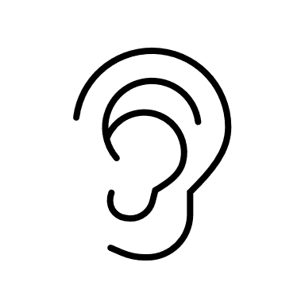Listen: What do you hear in the video that helps you better
understand how the community of Little Haiti identifies itself?

Watch: What do you see in the video that helps you better
understand how the community of Little Haiti identifies itself?

Little Haiti is a unique enclave community because _____________________
___________________________________________________________________
___________________________________________________________________.

Visual Analysis: The Art of Widline Cadet
What I See. What I think.
Photo 1:

Photo 2:

Photo 3:

Photo 4:

Photo 5:

