Handout A: My Cultural Mask Template
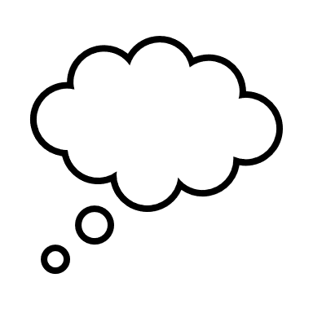 What symbols will I use? ___________________________________________
What colors are meaningful to me? ___________________________________
What do I want my mask to say about me? _____________________________
____________________________________________________________________________
____________________________________________________________________________.

