The Lyrical Moment: Modern and Contemporary Abstraction by Helen Frankenthaler and Heather Gwen Martin

University of South Florida Contemporary Art Museum
June 17-July 30, 2022
Teaching Resources

Helen Frankenthaler (1928-2011), whose career spanned six decades, has long been recognized as one of the great American artists of the 20th century. She was eminent among the second generation of postwar American abstract painters and is widely credited for playing a pivotal role in the transition from Abstract Expressionism to Color Field painting. Frankenthaler described her first encounter with Jackson Pollock’s work in 1951 as “a beautiful trauma.” As retold in Mary Gabriel’s 2018 book Ninth Street Women, that meeting “set her on a path of bold technical innovation and creation that would inspire others as it inspired her.”

Through her invention of the soak-stain technique, she expanded the possibilities of abstract painting, while at times referencing figuration and landscape in unique ways. She produced a body of work whose impact on contemporary art has been profound and continues to grow.

Frankenthaler experimented tirelessly throughout her long career. In addition to producing unique paintings on canvas and paper, she worked in a wide range of media, including ceramics, sculpture, tapestry, and especially printmaking. Hers was a significant voice in the mid-century “print renaissance” among American abstract painters. She continued to work and exhibit through the opening years of this century.

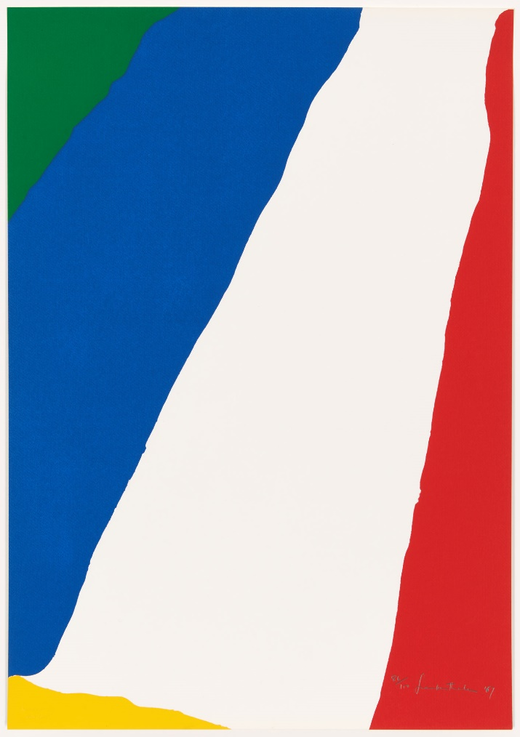
Helen Frankenthaler, Untitled, 1967. Screenprint, 25-3/4 x 17-7/8 in. Edition 86/100. © Helen Frankenthaler Foundation, Inc. / Artists Rights Society (ARS), New York / Chiron Press, New York. Photography by Will Lytch.
L.A.-based artist Heather Gwen Martin (1977- ) has been creating paintings that walk a tightrope between improvisation and deliberation, dissolution, and structure. While a full-time student at the University of California San Diego—where she studied with Pattern and Decoration pioneer Kim McConnell—Martin worked as a colorist for DC comics, adding color onto scenes and characters using computer technology. The experience had an unintended but profound effect on her painting.

Today, Martin’s canvases resemble splash pages for certain copyrighted film or screen-based entertainments. Nonetheless her vividly colored abstractions remain one hundred percent handmade, containing no high-tech aides or digital fillers. Denuded of figures, captions and word balloons, her sprightly landscapes distill reflection and sensation into loops of sinuous line and flat areas of color. While some canvases superficially resemble the livelier aspects of swipe-and-like looking—rounded emoji-like shapes and abrupt transitions between bright areas of color—they impress sensorially, like the taste of underripe fruit or a sharp intake of cold breath.
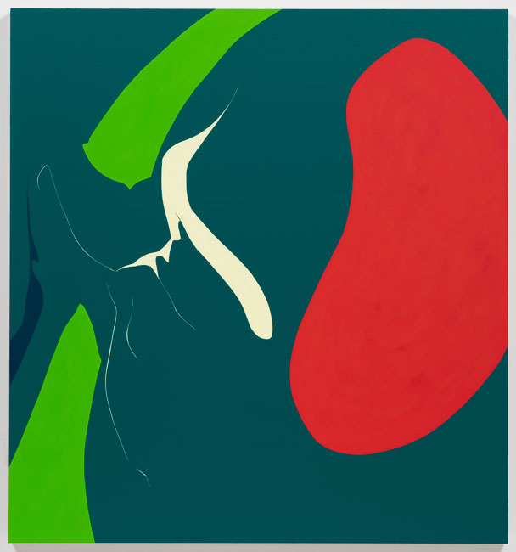
Heather Gwen Martin, Fever Dream, 2021. Oil on linen, 60 x 56 in. © Heather Gwen Martin. Courtesy of L.A. Louver, Los Angeles and Miles McEnery, New York. Photography by Jeff McLane.

Teaching Resources

Websites
The Lyrical Moment (USF Contemporary Art Museum)
http://ira.usf.edu/CAM/exhibitions/2022_06_The_Lyrical_Moment/The_Lyrical_Moment.html

Abstract Expressionism (Tate Museum)
https://www.tate.org.uk/art/art-terms/a/abstract-expressionism

Abstract Expressionism (Metropolitan Museum of Art)
https://www.metmuseum.org/toah/hd/abex/hd_abex.htm

Abstract Expressionist Artists You Need to Know (Artworks)
https://www.ideelart.com/magazine/abstract-expressionist-artists

Heather Gwen Martin (Miles McEnery Gallery)
https://www.milesmcenery.com/artists/heather-gwen-martin

Helen Frankenthaler (WikiArt Visual Art Encyclopedia)
https://www.wikiart.org/en/helen-frankenthaler

Who was Helen Frankenthaler? (Art in America: Art News)
https://www.artnews.com/feature/helen-frankenthaler-who-is-she-why-is-she-important-1234586555/

Print Materials
Belasco, D. (2014). See us now: The feminist positions of Helen Frankenthaler and Grace Hartigan, 1957-1962. Konsthistorisk Tidskrift 83(2), 67-81.

Chave, A. C. (2016). Frankenthaler’s fortunes: On class privilege and the artist’s reception. Women’s Art Journal, 37(1), 29-36.

Gabriel, M. (2019). Ninth Street women: Lee Krasner, Elaine de Kooning, Grace Hartigan, Joan Mitchell, and Helen Frankenthaler: Five painters and the movement that changed modern art. Back Bay Books.

Nemerov, A. (2021). Fierce poise: Helen Frankenthaler and 1950s. Penguin Press.

Rowley, A. (2007). Helen Frankenthaler: Painting history, writing painting. Palgrave Macmillan.

Sandler, I. (2016). Women of abstract expressionism. Yale University Press.

Wilkin, K. (2012). Helen Frankenthaler (1928-2011). American Art 26(3), 100-104.

Videos

"Know the Artist: Helen Frankenthaler" on YouTube
https://youtu.be/dOkrCOslfcU

"Desire Is the Theme of All Life: Helen Frankenthaler in 1950s New York with Alexander Nemerov" on YouTube
https://www.youtube.com/watch?v=vDFfAI4feII

"Arts District: Women of Abstract Expressionism" on YouTube
https://www.youtube.com/watch?v=p7tlfBOjay0

“From 1984: Abstract expressionist Helen Frankenthaler" on YouTube
https://www.youtube.com/watch?v=pBKNifpTSFk&feature=youtu.be

"Helen Frankenthaler interview (1993)" on YouTube
https://www.youtube.com/watch?v=AxQw7SNO9yA

“Portrait of the artist Helen Frankenthaler" on YouTube
https://www.youtube.com/watch?v=7efK8UTjlzY&feature=youtu.be

"Getting to the truth of things with abstraction | Helen Frankenthaler | UNIQLO ARTSPEAKS" on YouTube
https://www.youtube.com/watch?v=rgvnESHZm_M

"Helen Frankenthaler: Line into Color, Color into Line" on YouTube
https://youtu.be/h35AJ2cn72Y

“Helen Frankenthaler and the Women of Abstract Expressionism” on YouTube
https://www.youtube.com/watch?v=6H-JICBOwjQ

“Heather Gwen Martin: Fever Dream” on YouTube
https://www.youtube.com/watch?v=i5wvW-cVowc

“In Conversation with Heather Gwen Martin” on YouTube
https://www.youtube.com/watch?v=xVGuljK51VI

“The Science of Color with Heather Gwen Martin and Gershom” on YouTube
https://www.youtube.com/watch?v=DoE7t-q5nwM

“Art District: Women of Abstract Expressionism” on YouTube
https://www.youtube.com/watch?v=p7tlfBOjay0

“Fields of Colour: Helen Frankenthaler”
https://www.youtube.com/watch?v=GtwDEgSIkbw

